

MIDDLE EAST TECHNICAL UNIVERSITY

DEPARTMENT OF CIVIL ENGINEERING

CE482- DESIGN OF STEEL STRUCTURES

Term Project

Instructor

Prof. Dr. Oğuzhan HASANÇEBİ

Prepared by

06.06.2018

**TABLE OF CONTENT**

Information about Structure…...……………………………………………………………….2

Sketches of SAP2000 Model.…………….…………………………………………………....3

Economical Section...………………………………………………………………………....20

References………………………………………………………………………………….....21

**INFORMATION ABOUT STRUCTURE**

Building:

An industrial building is designed and it is one-bay by four-bay. The structure has 16 m spacing in one-bay direction and 4 m spacing in four-bay direction, so both directions have total 16 m spacing. The height from the base to bottom chord is 6 meters and to top chord is 8 meters. The building has 9.5 meters height. It consists of steel columns and trusses and a concrete roof. All the steel columns are HSS sections and they are of S275 steel grade. The truss members are selected from W shapes. The concrete roof have 10 cm thick and the concrete is of grade C20. All the columns are pin-connected to the ground.

Loading:

Dead load = 90 kN

Live load = 1.5 kPa (on the roof)

Wind load = 0.7 kPa (on the windward side)

= 0.3 kPa (on the leeward side)

Load combinations:

1.4DL

1.2DL + 1.6LL

1.2DL + 1.0LL + 1.6WL

**SKETCHES OF SAP2000 MODEL**

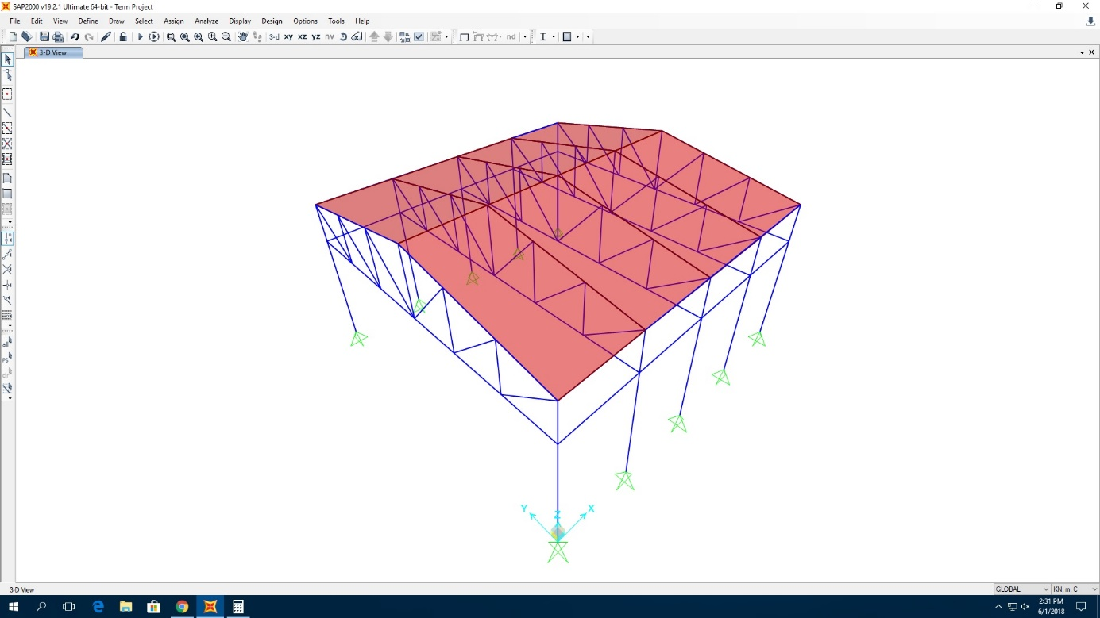

**Figure 1.** View of 3D model

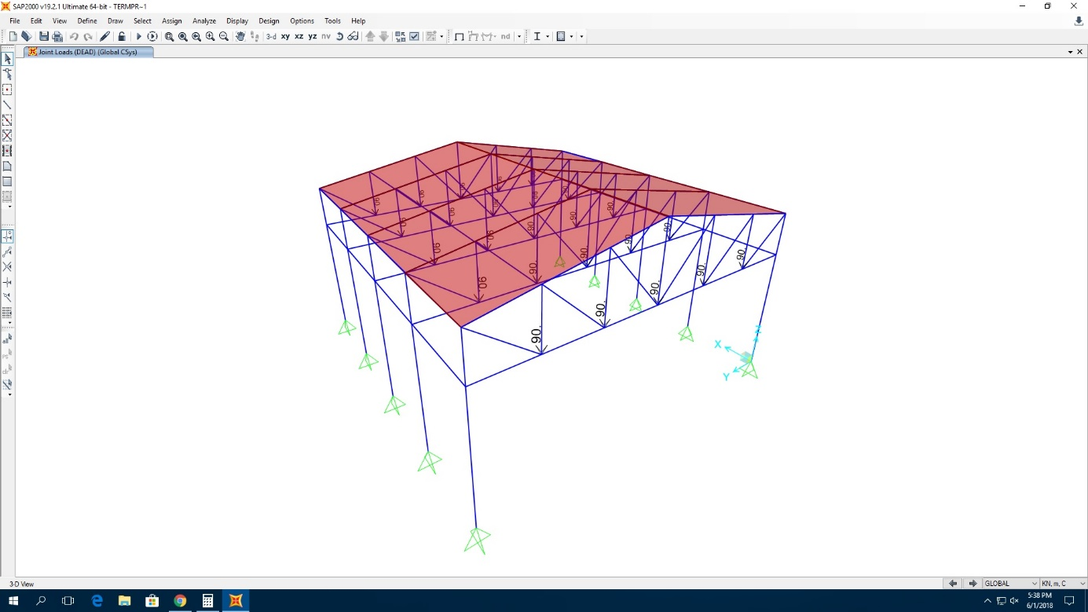

**Figure 2.** Dead loads acting on the structure

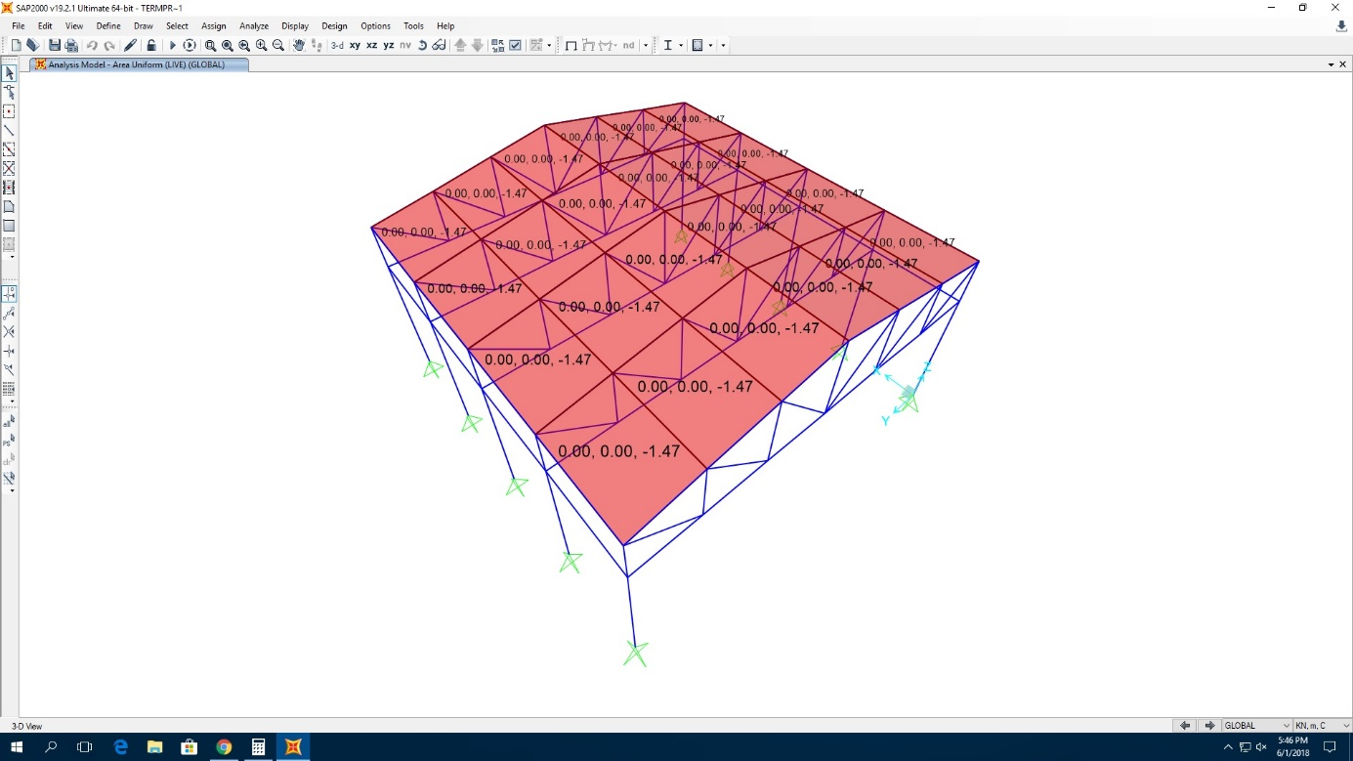

**Figure 3.** Live loads acting on the structure

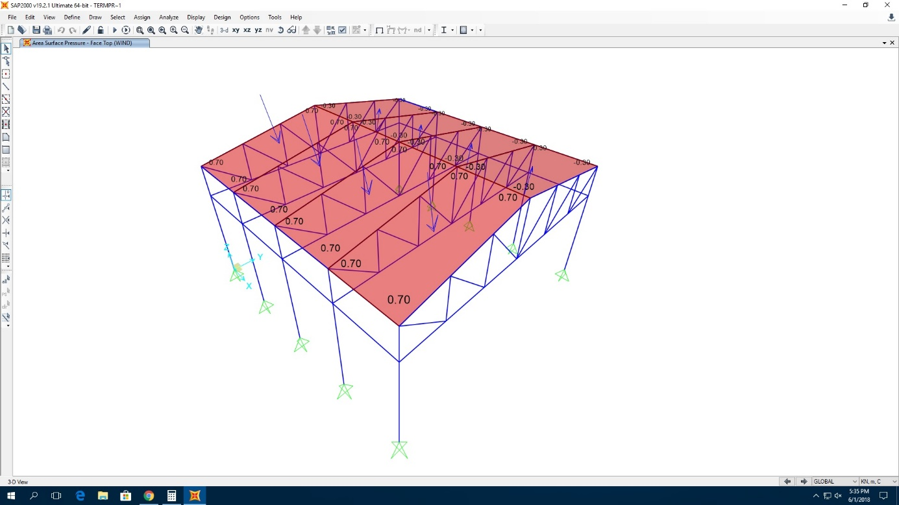

**Figure 4.** Wind loads acting on the structure

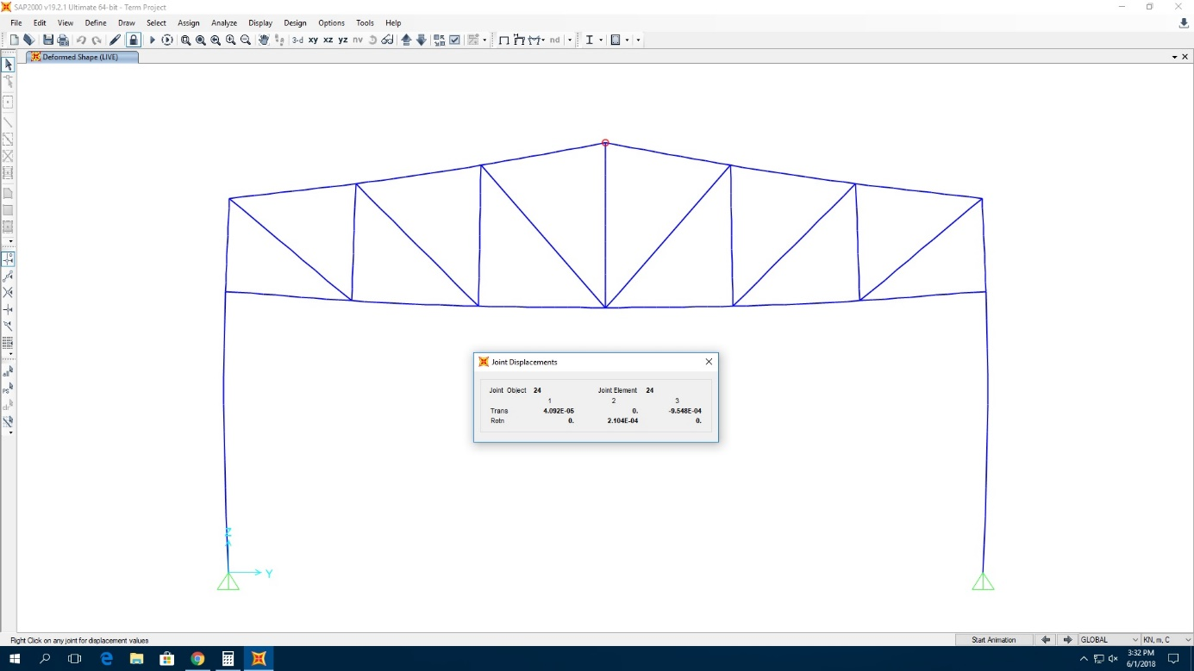

**Figure 5.** Deformed shape of the structure under live loads (on Y-Z plane at x=0) and displacement of the selected joint

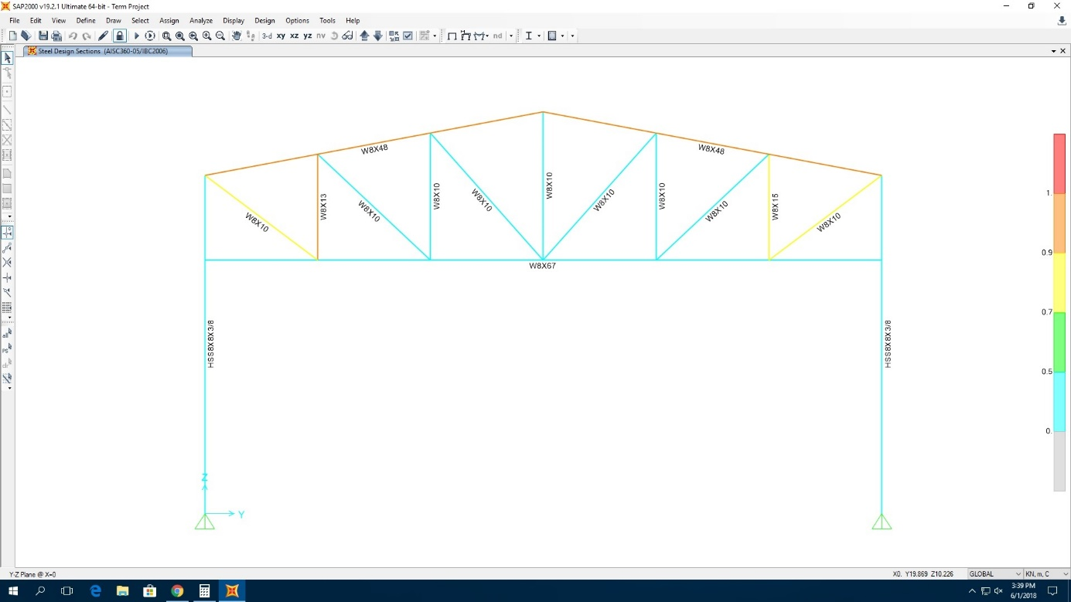

**Figure 6.** First model that obtain after designing the steel frame objects (on Y-Z plane at x=0)

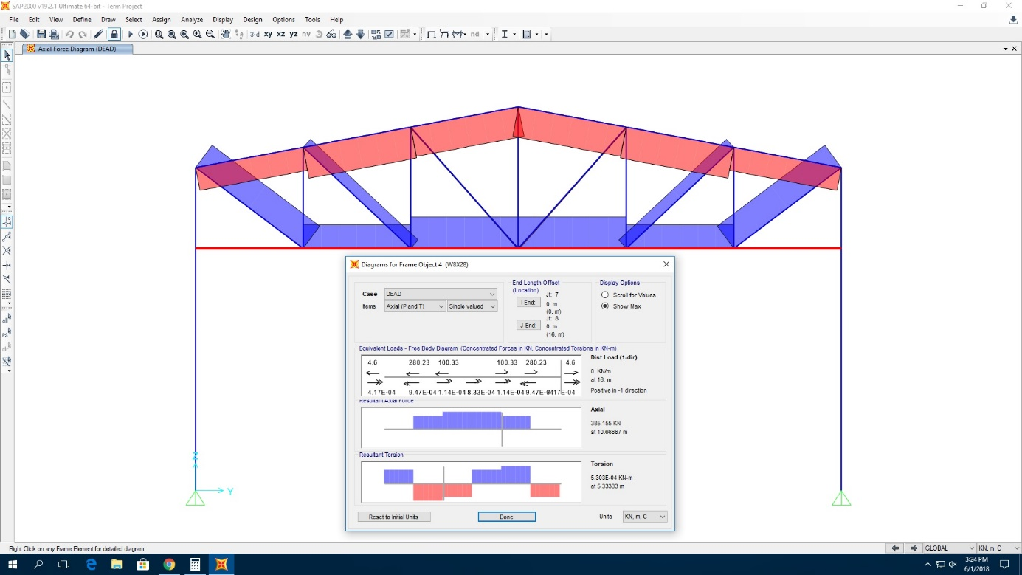

**Figure 7.** Axial force details of bottom and top chords and truss members under dead load

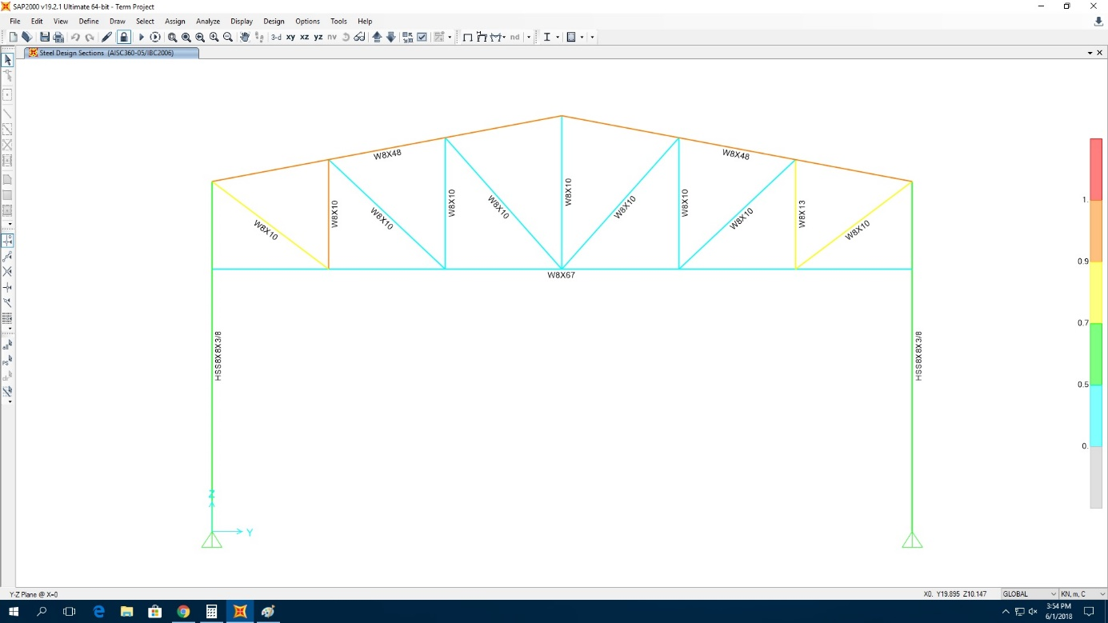

**Figure 8.** Second model that obtain after designing the steel frame objects (on Y-Z plane at x=0)

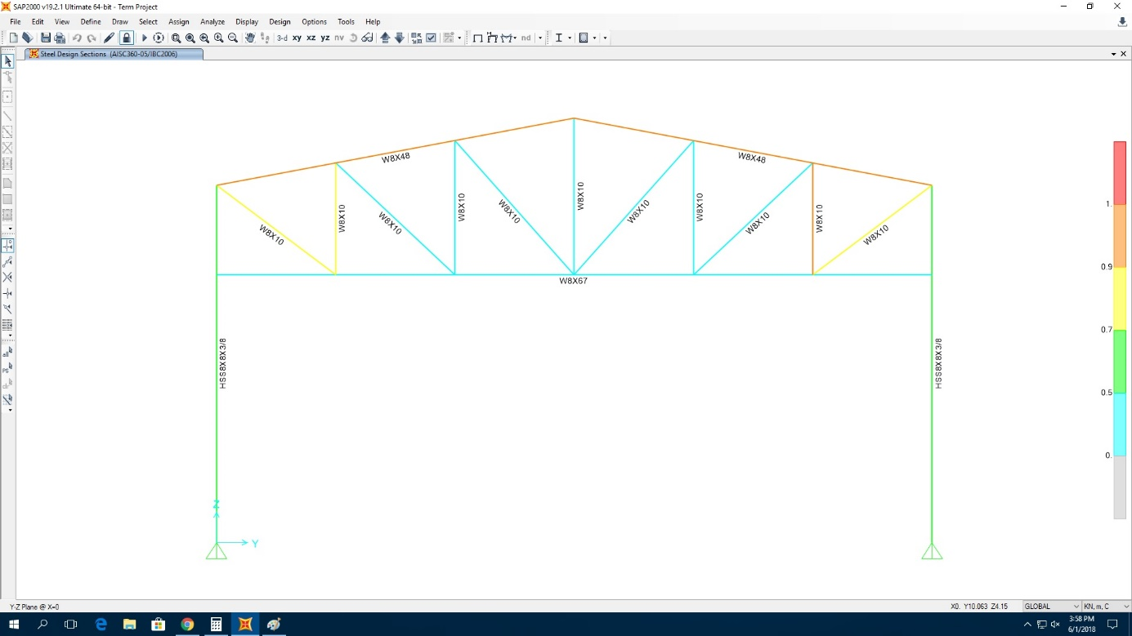

**Figure 9.** Third model that obtain after designing the steel frame objects (on Y-Z plane at x=0)

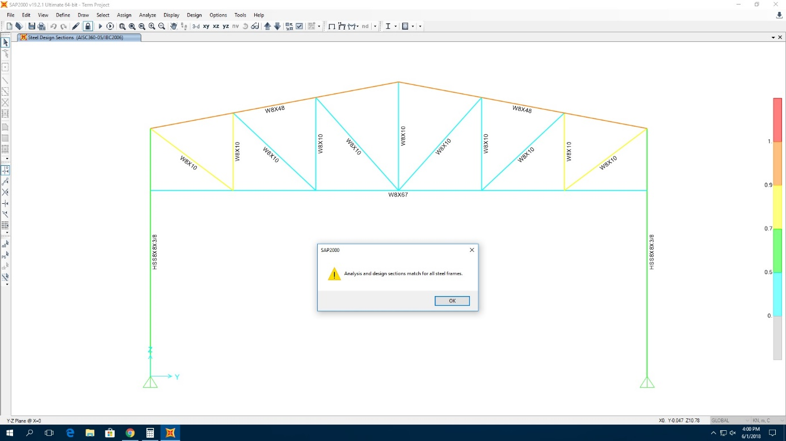

**Figure 10.** Final model that obtain after designing the steel frame objects (all sections are matched) (on Y-Z plane at x=0)

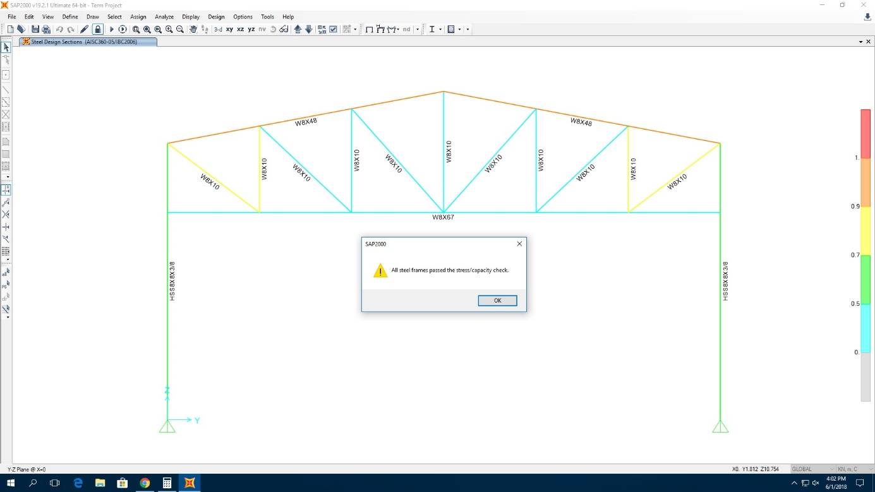

**Figure 11.** Final model that obtain after designing the steel frame objects (all sections are checked)

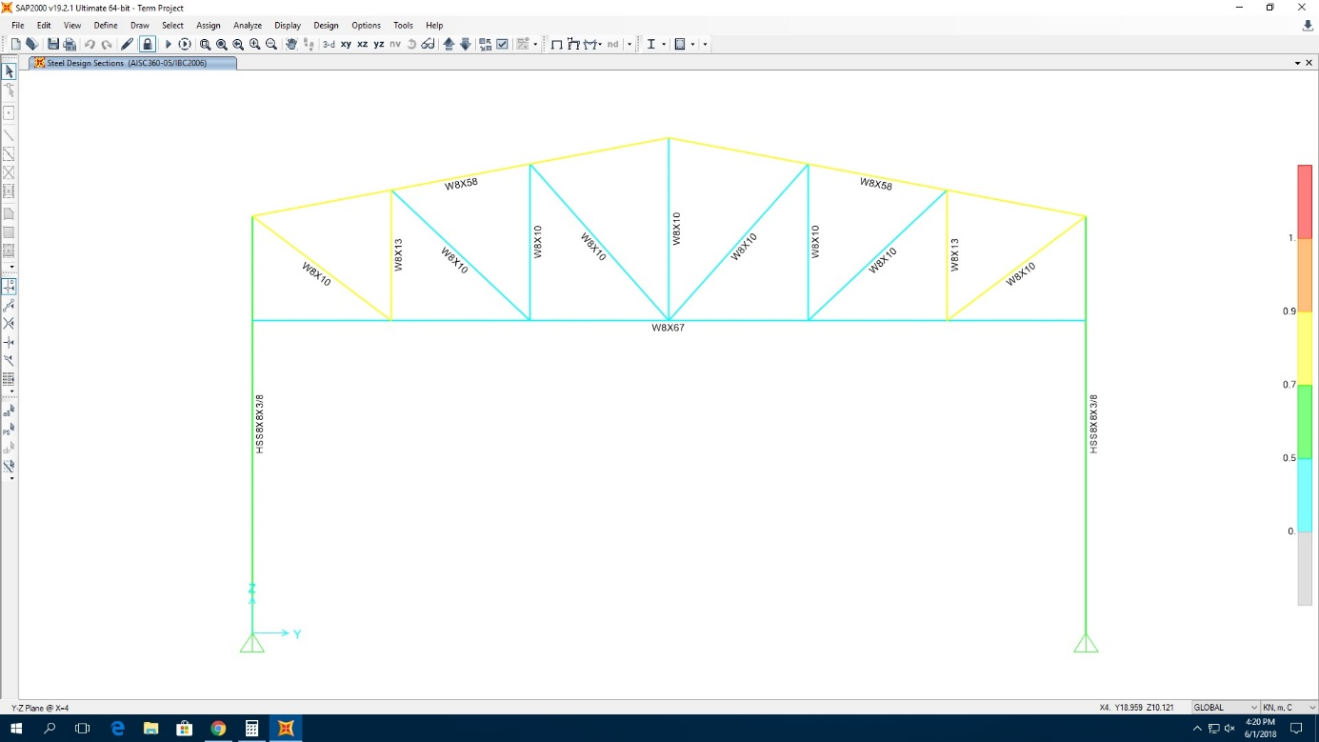

**Figure 12.** Final model that obtain after designing the steel frame objects (on Y-Z plane at x=4)

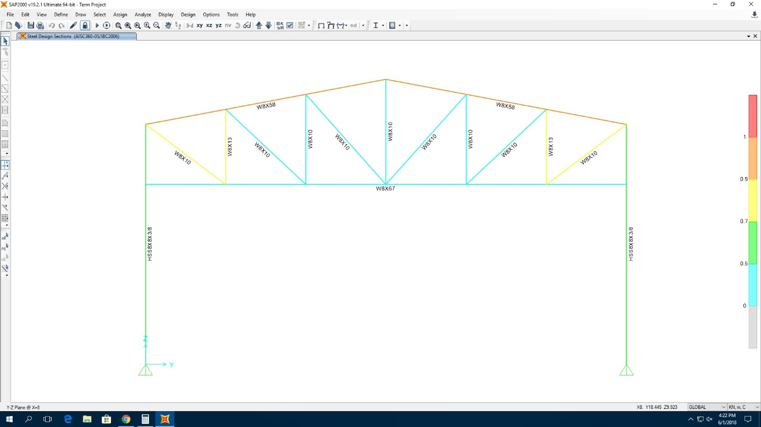

**Figure 13.** Final model that obtain after designing the steel frame objects (on Y-Z plane at x=8)

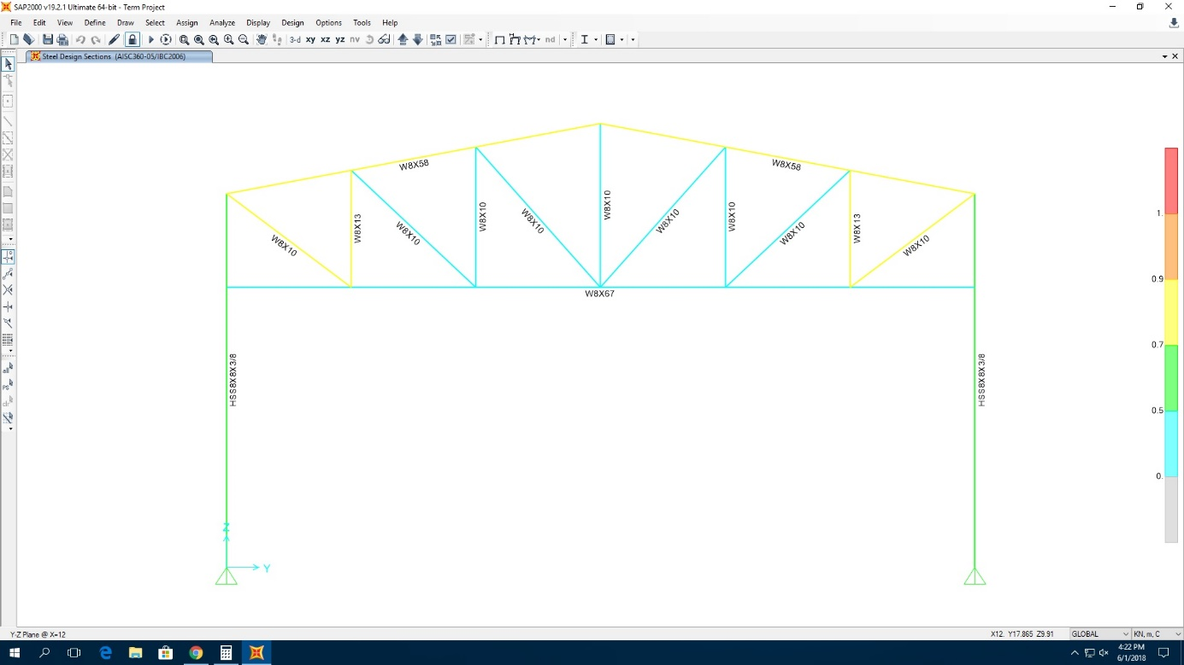

**Figure 14.** Final model that obtain after designing the steel frame objects (on Y-Z plane at x=12)

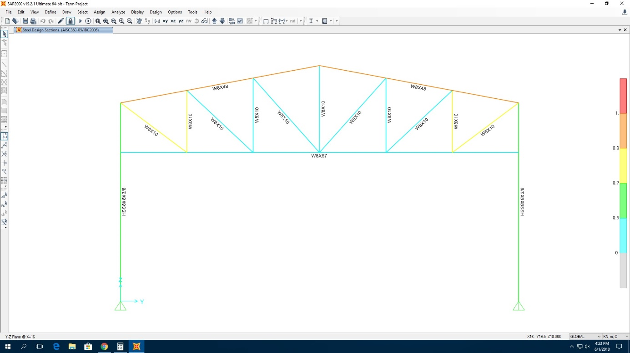

**Figure 15.** Final model that obtain after designing the steel frame objects (on Y-Z plane at x=16)

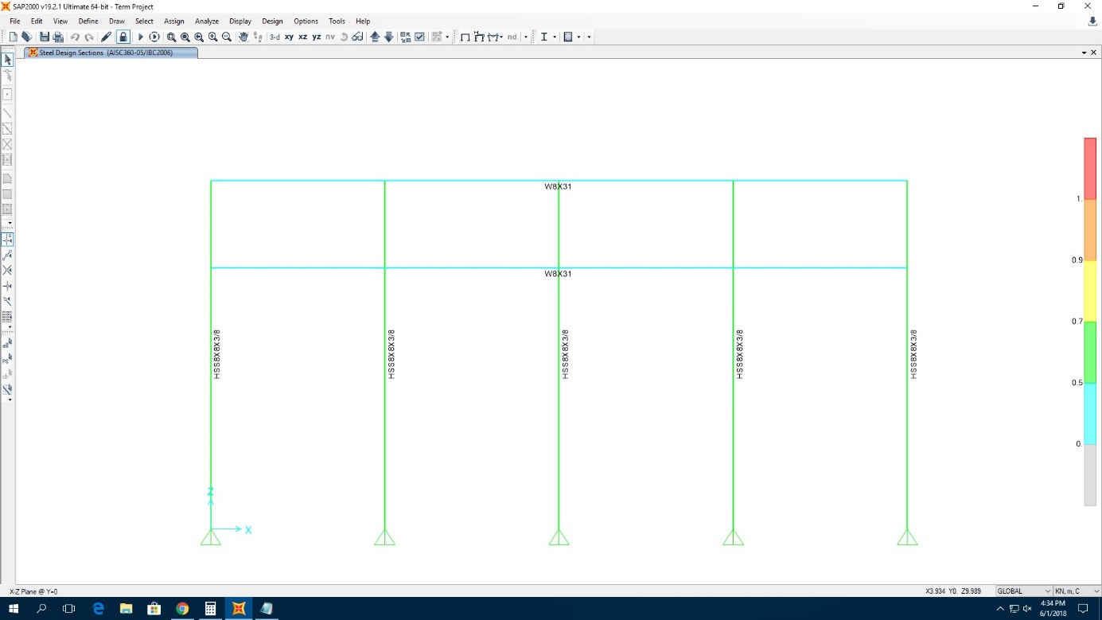

**Figure 16.** Final model that obtain after designing the steel frame objects (on X-Z plane at y=0)

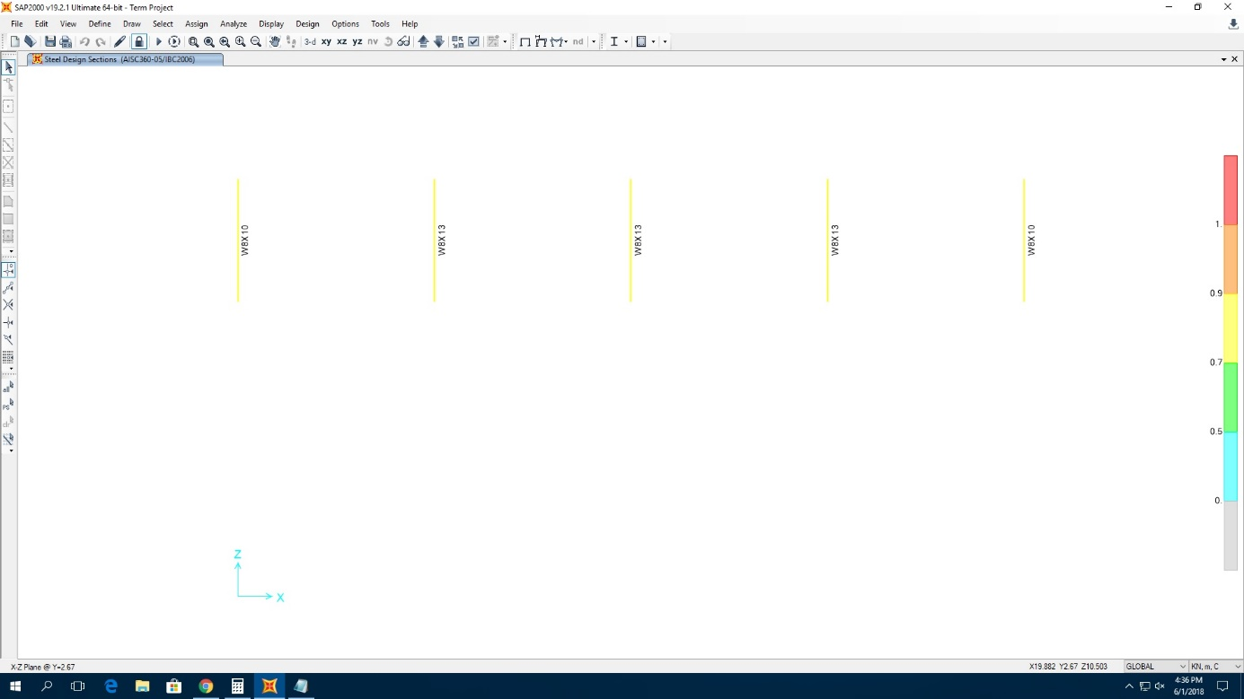

**Figure 17.** Final model that obtain after designing the steel frame objects (on X-Z plane at y=2.67)

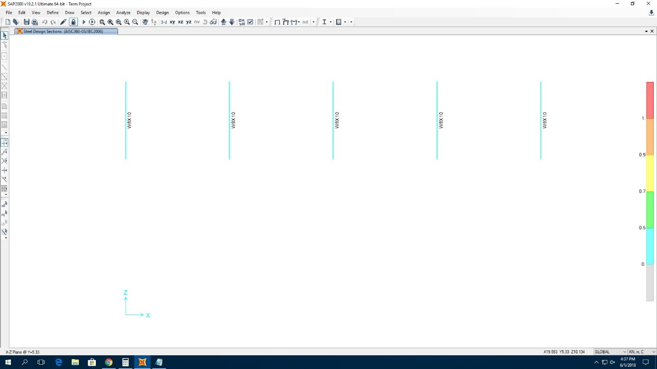

**Figure 18.** Final model that obtain after designing the steel frame objects (on X-Z plane at y=5.33)

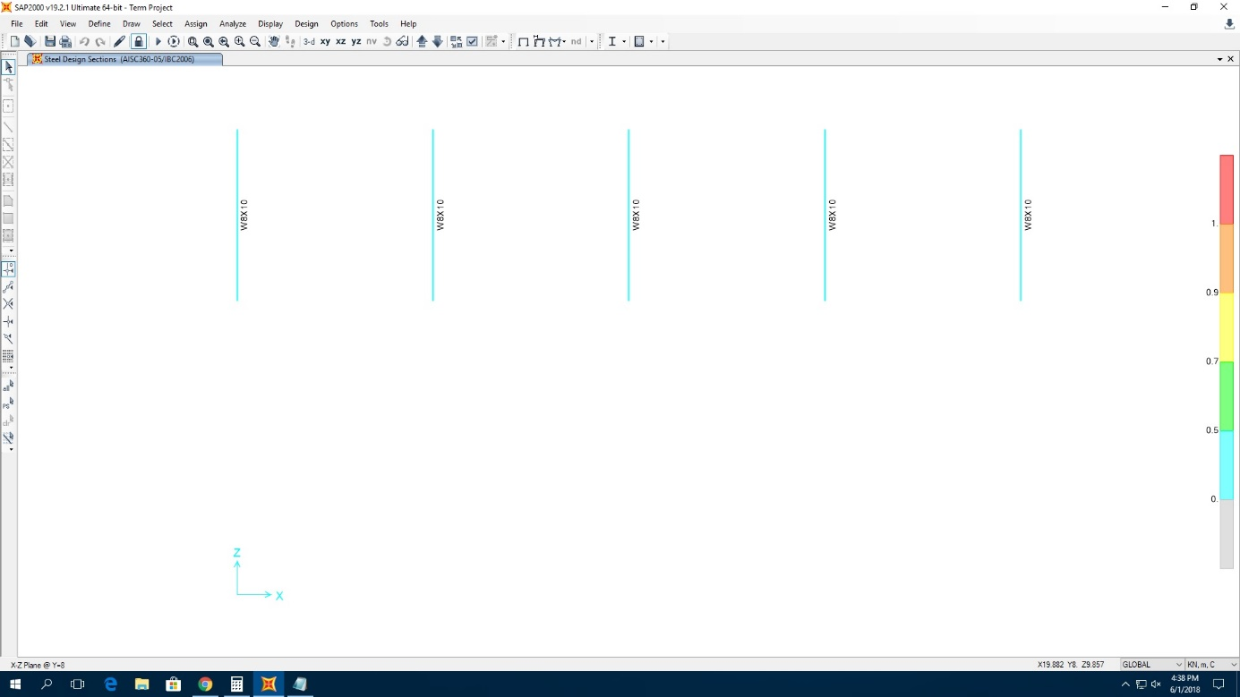

**Figure 19.** Final model that obtain after designing the steel frame objects (on X-Z plane at y=8.00)

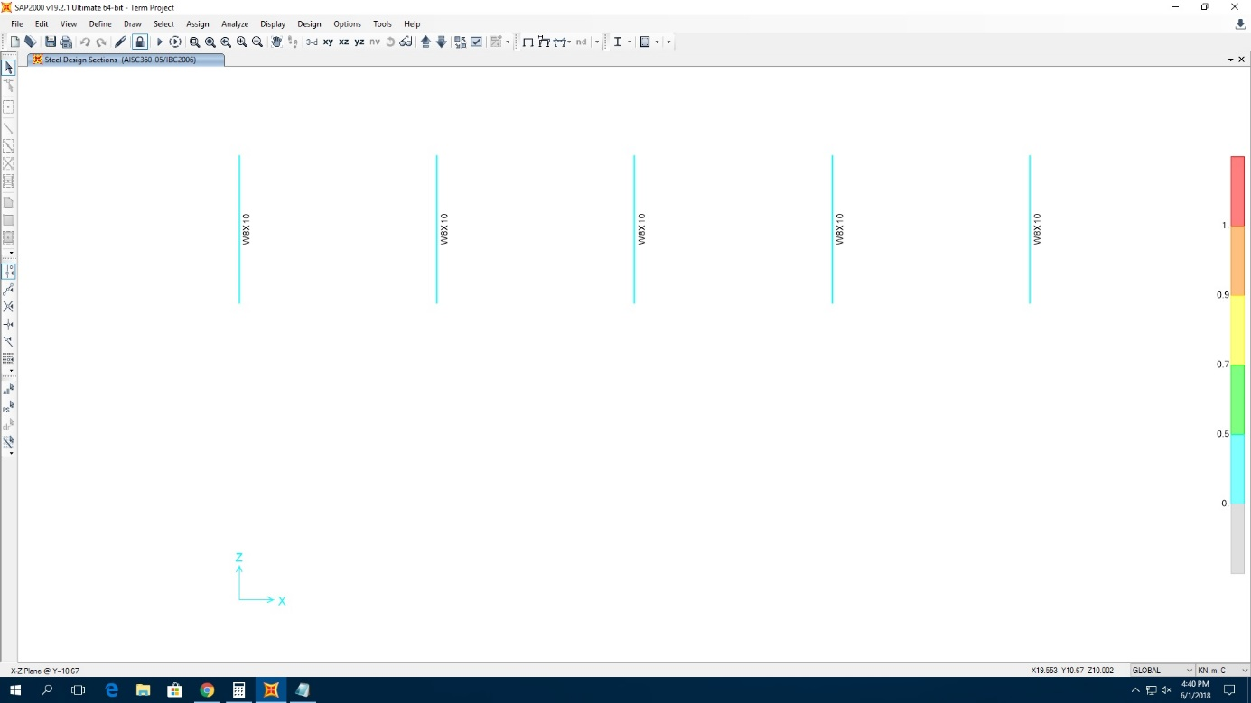

**Figure 20.** Final model that obtain after designing the steel frame objects (on X-Z plane at y=10.67)

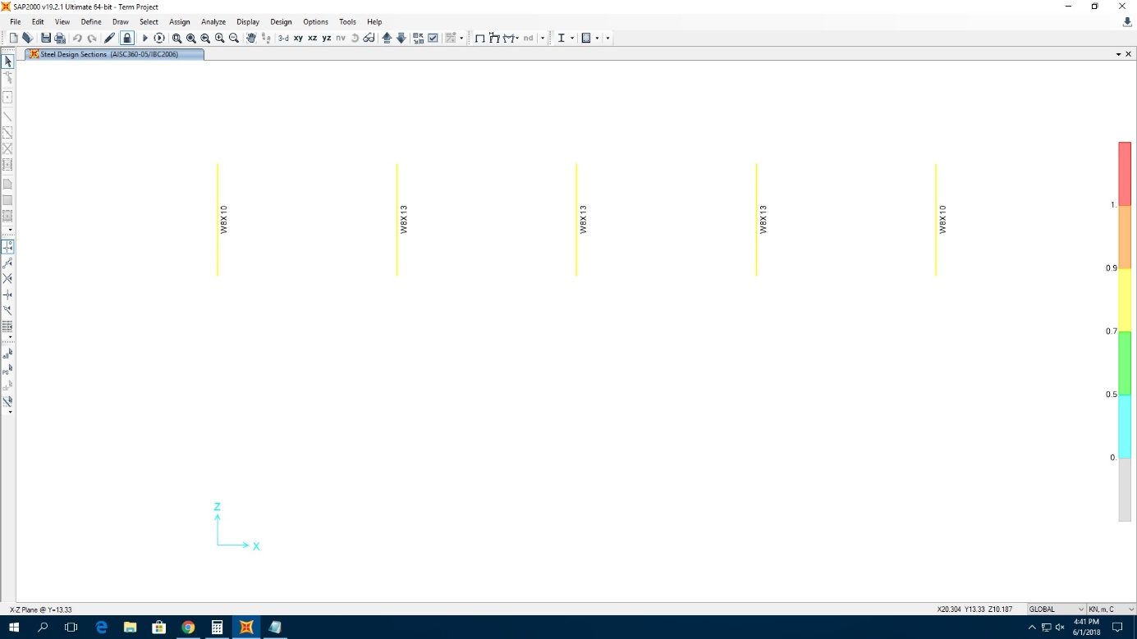

**Figure 21.** Final model that obtain after designing the steel frame objects (on X-Z plane at y=13.33)

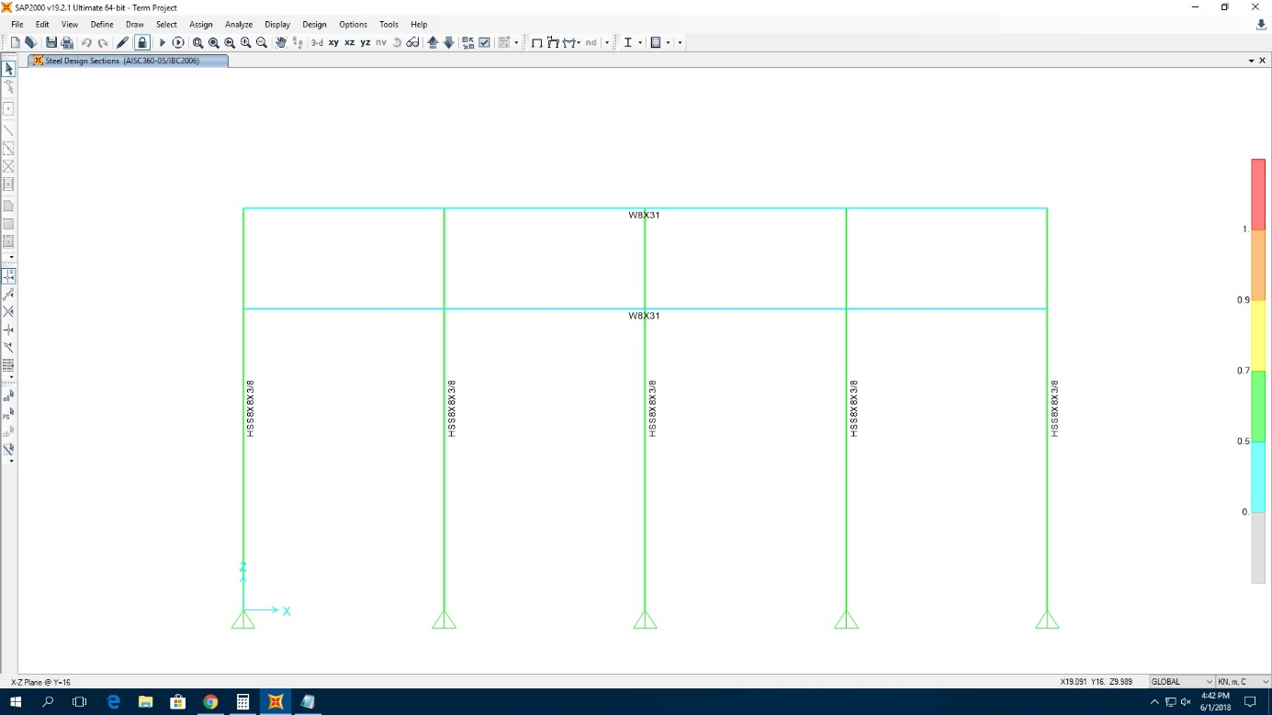

**Figure 22.** Final model that obtain after designing the steel frame objects (on X-Z plane at y=16.00)

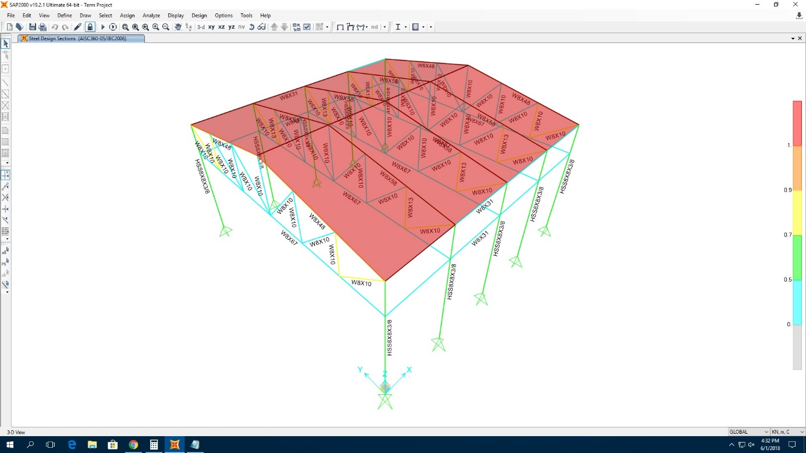

**Figure 23.** 3D model structure after the design is finished

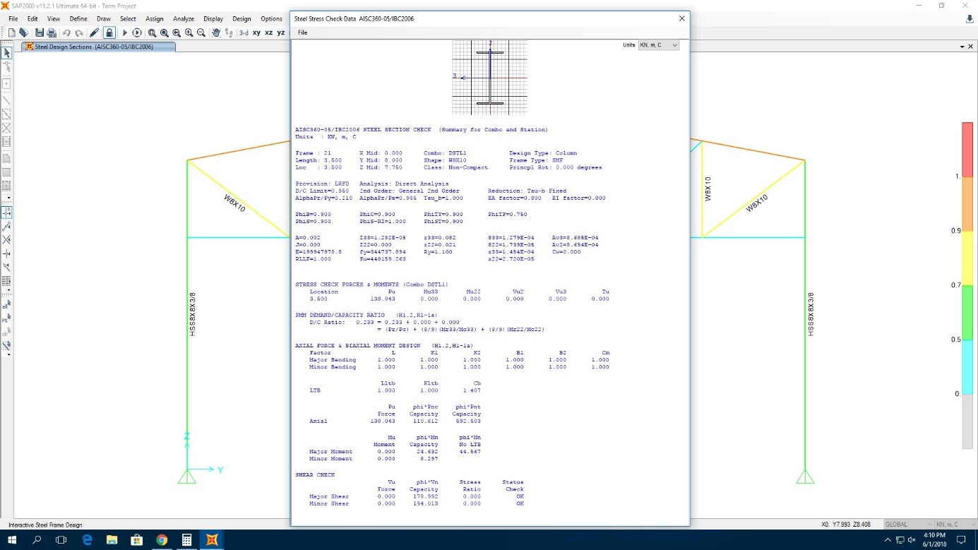

**Figure 24.** Section and section properties of W8x10 truss member

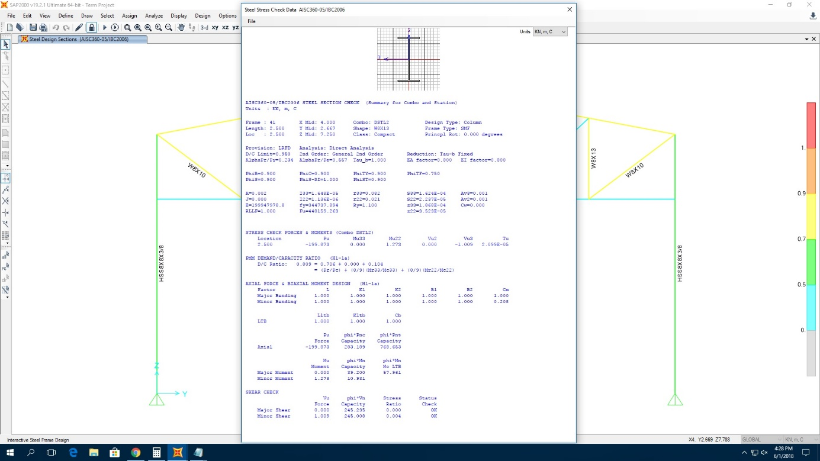

**Figure 25.** Section and section properties of W8x13 truss member

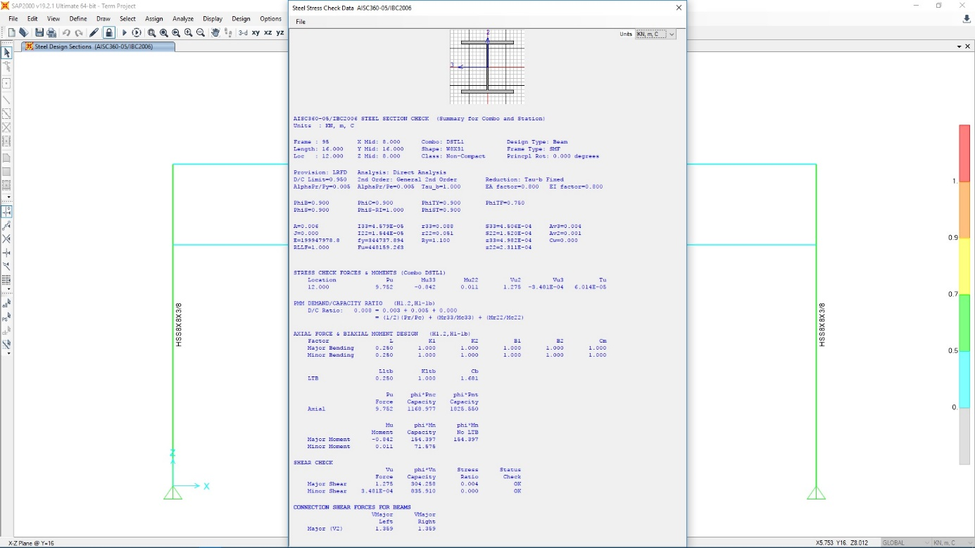

**Figure 26.** Section and section properties of W8x31 truss member

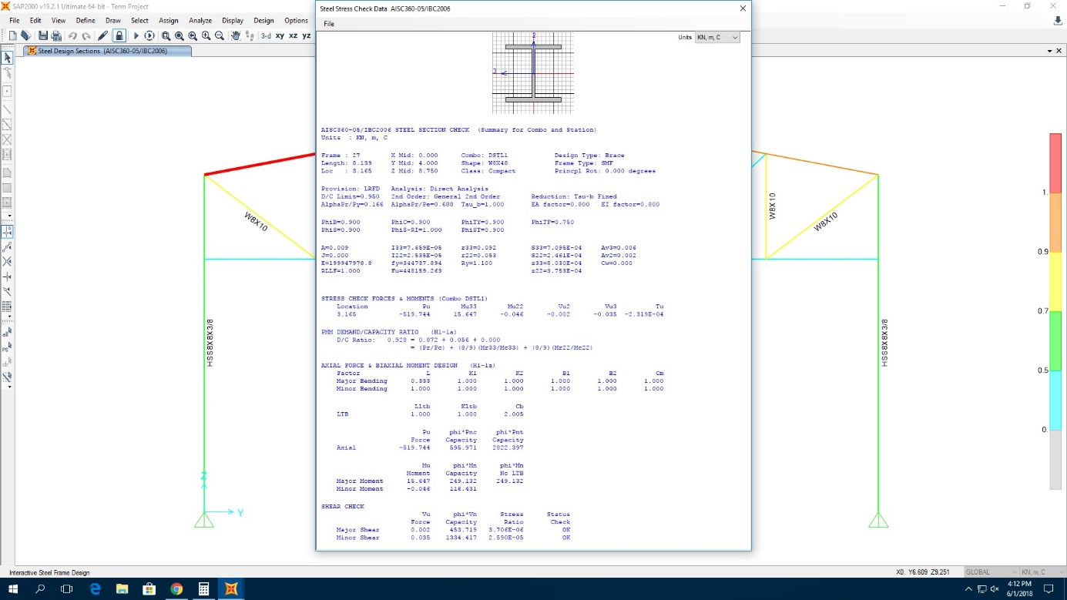

**Figure 27.** Section and section properties of W8x48 truss member

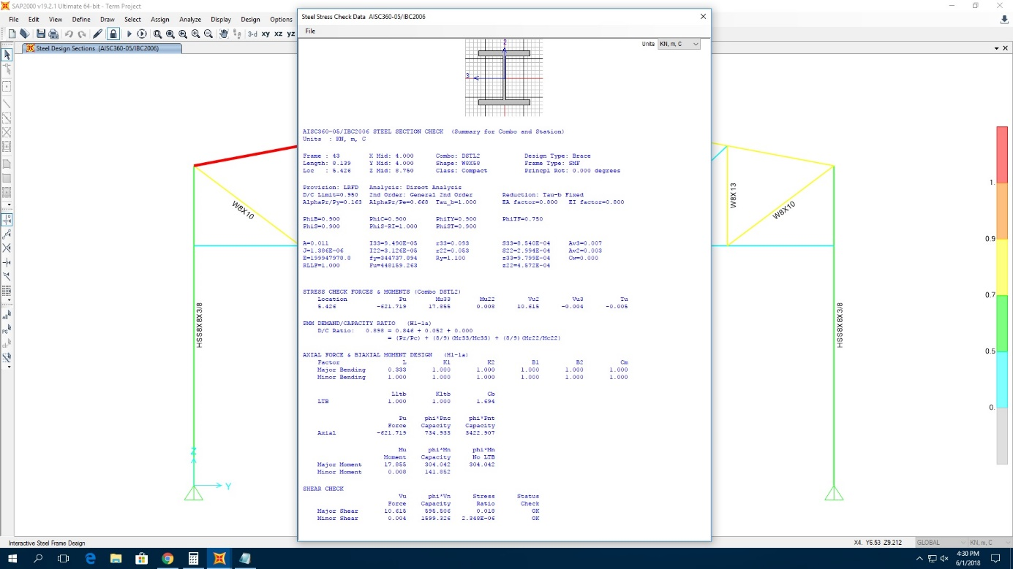

**Figure 28.** Section and section properties of W8x58 truss member

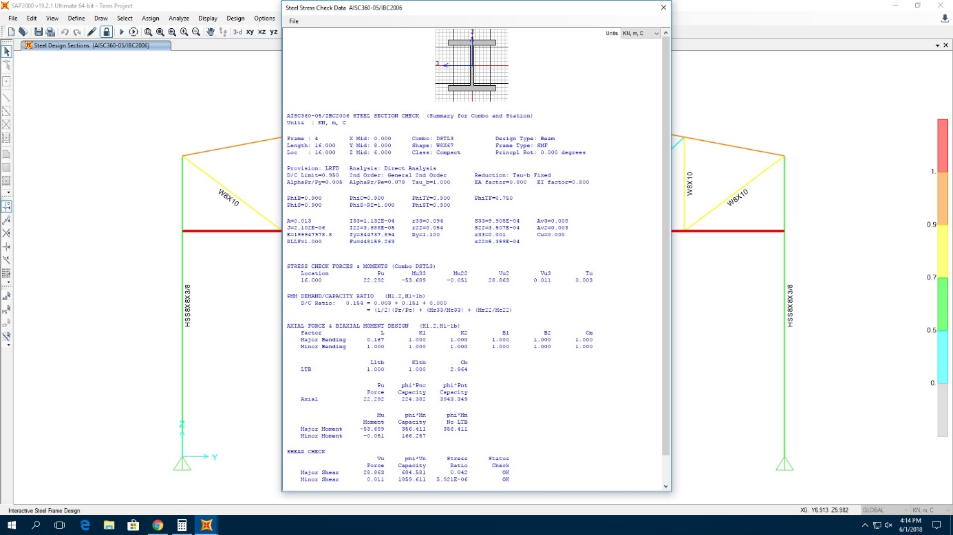

**Figure 29.** Section and section properties of W8x67 truss member

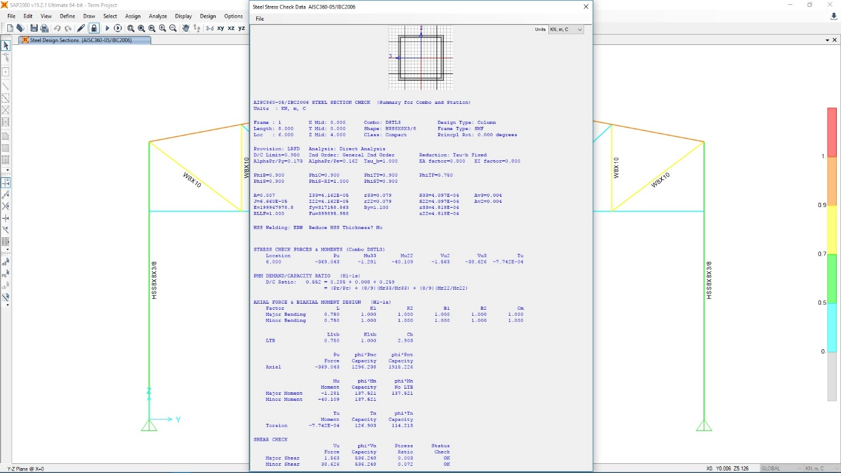

**Figure 30.** Section and section properties of HSS8X8X3/8 column member

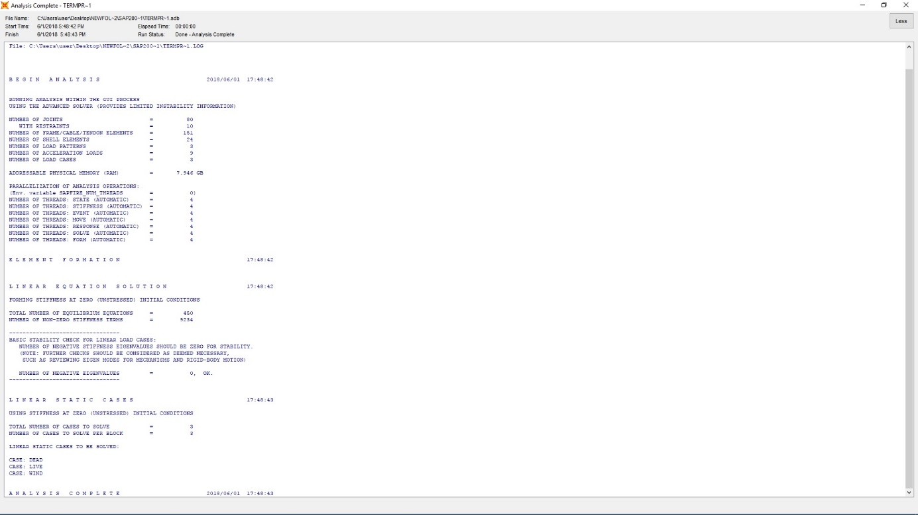

**Figure 31.** Data obtained after analysis

**ECONOMICAL SECTION**

All steps are made in the SAP2000 program and it utilizes the AISC 360-05 specification.

|  |  |  |  |  |
| --- | --- | --- | --- | --- |
| TABLE: Material List 2 - By Section Property | | | |  |
| Section | ObjectType | NumPieces | TotalLength | TotalWeight |
| Text | Text | Unitless | m | KN |
| HSS8X8X3/8 | Text | 10 | 80 | 41,317 |
| W8X10 | Text | 49 | 167,52484 | 24,625 |
| W8X13 | Text | 6 | 15 | 2,86 |
| W8X31 | Text | 4 | 64 | 28,985 |
| W8X48 | Text | 4 | 32,55764 | 22,797 |
| W8X58 | Text | 6 | 48,83646 | 41,471 |
| W8X67 | Text | 5 | 80 | 78,264 |
| ROOF | Text |  |  | 613,728 |

**Table 1.** The number, total length and total weight of all pieces of the structure

Total steel used in the structure is

= 41.317+ 24.625 + 2.86+ 28.985 + 22.797 + 41.471 + 78.264

= 240.229 kN

Total steel used per m2 in the structure is

(1 kN= 101.9716 kg)

= (240.229*101.9716)/ (16*16)

= 95.6896 kg/ m2

**REFERENCES**

1. ANSI/AISC 360-05 Specification for Structural Steel Buildings, AISC Committee on Specifications, March 9, 2005.
2. ASTM A500 / A500M-18, Standard Specification for Cold-Formed Welded and Seamless Carbon Steel Structural Tubing in Rounds and Shapes, ASTM International, West Conshohocken, PA, 2018, www.astm.org